NEWSLETTER

January 2023

Castle House Nursing Home Ltd.
We Care Enough To Make A Difference
IN THIS ISSUE

  - Editors Desk ..………… 2
  - Month in Review ………. 3
  - Upcoming Events …….. 5
  - January Calendar ……… 6
  - January Birthdays …….. 7
  - A Poem to Share .…….. 8
  - Noticeboard ……………. 9
  - Laughing Matters …….. 11
  - Spotlight ………………… 12
  - Word Search .…………… 13

Editor’s Desk
Hello Residents, Families and Friends!
Welcome Back! We hope you had a wonderful Christmas and New Year. Thank you for all of the kind gifts sent in for the staff, they were appreciated.
A huge thank you to Jo and Rob for the Christmas Party, everyone will agree it was a fabulous day and we are all grateful.
We have lots of fun activities planned for the year ahead year, which includes Elvis here in the building to perform for us monthly and lots more.
Thank you for all your continued support!
Keep Safe!
Lou
Quote of the Day
You can’t help getting older, but you don’t have to get old.

– George Burns
January Trivia

January was named after the Roman god Janus; the god of beginnings & transitions.

Zodiac signs: Capricorn & Aquarius
Birthstone: Garnet
Flower: Carnations

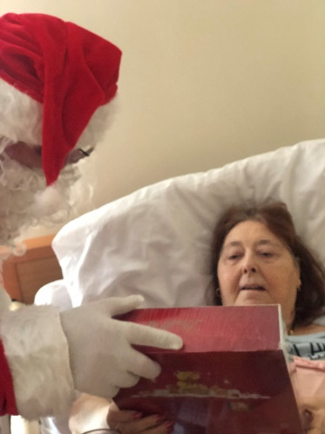
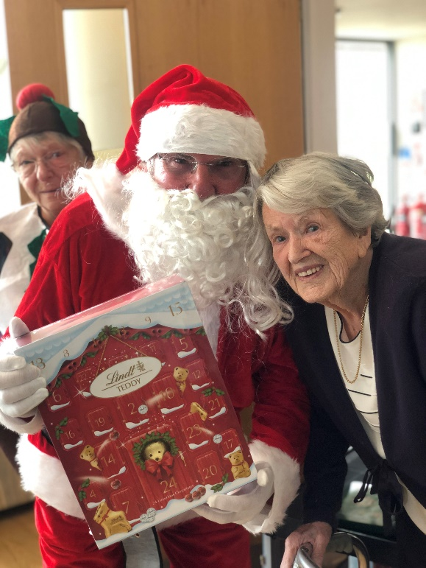
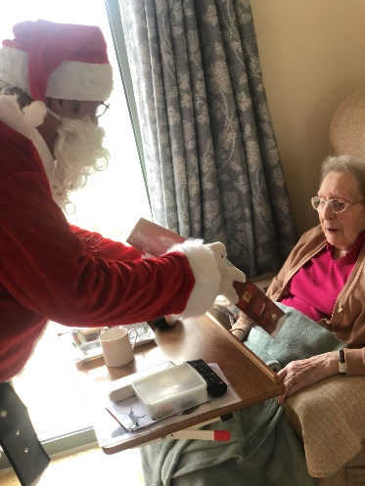
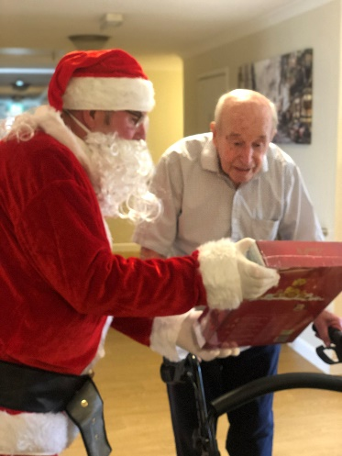
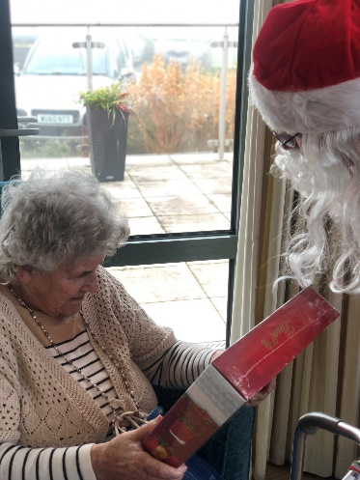
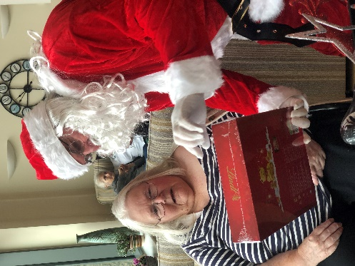
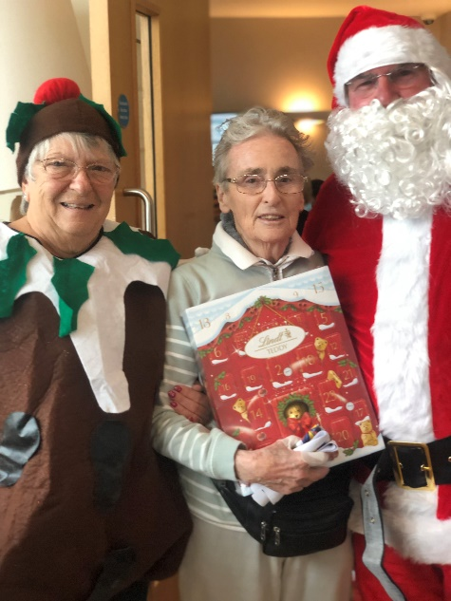
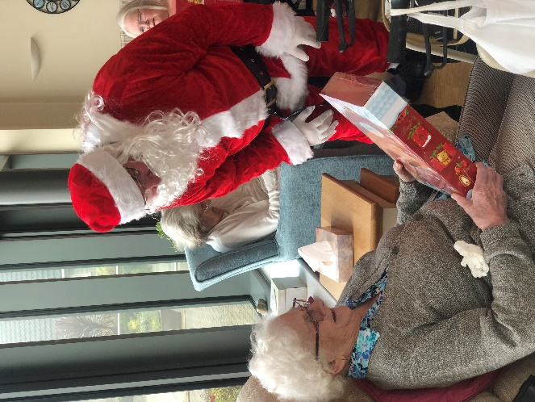
December
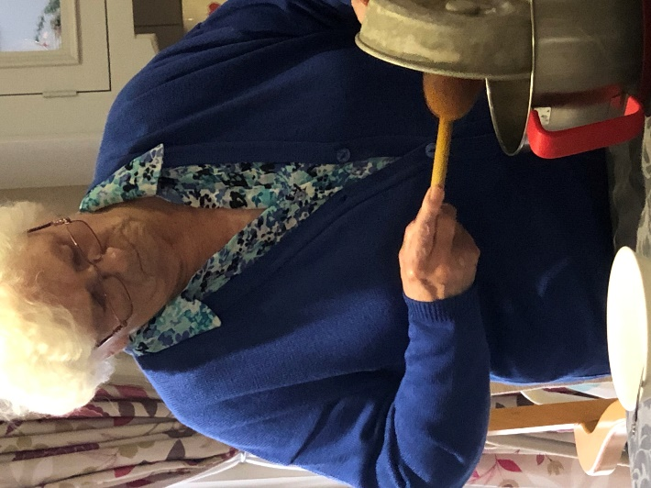
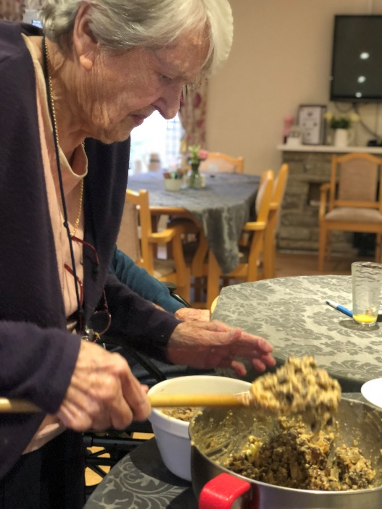
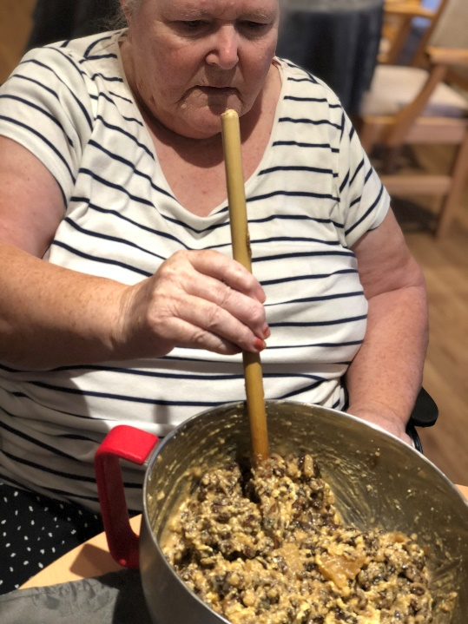
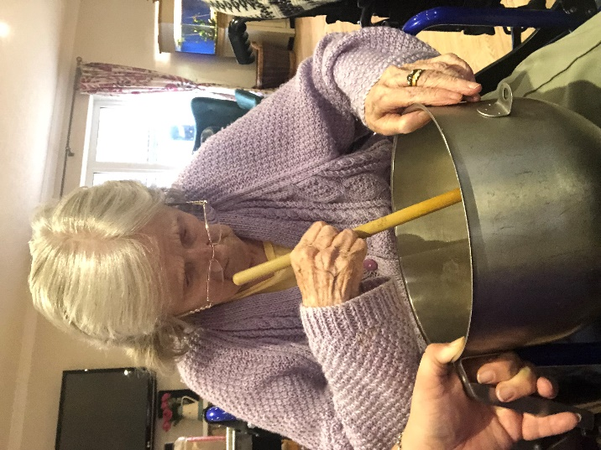
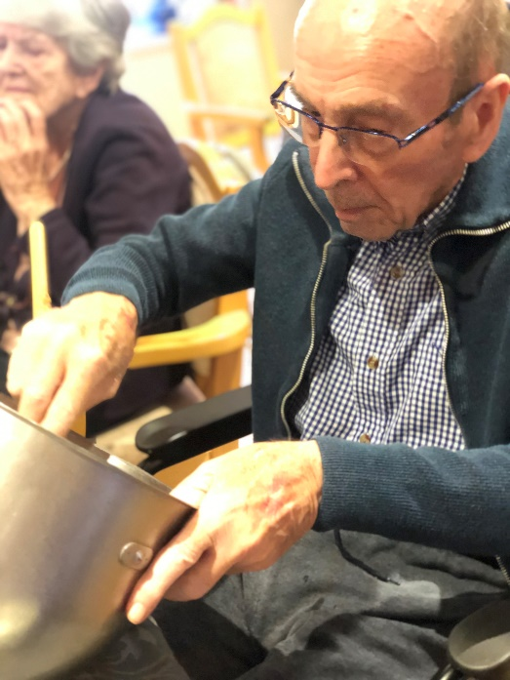
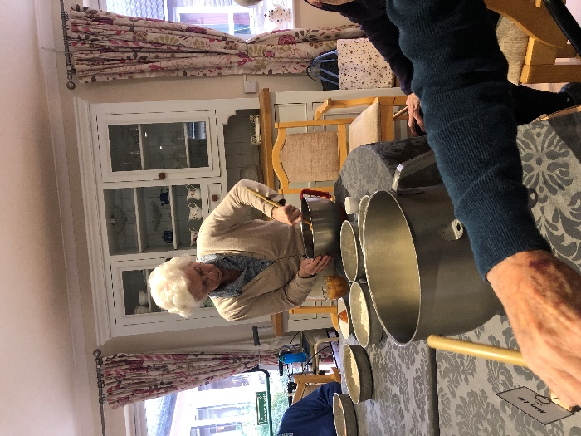

We made our own Christmas Pudding this year and it was delicious!

Everyone had a stir and made a wish

We included some random ingredients that seemed to work well

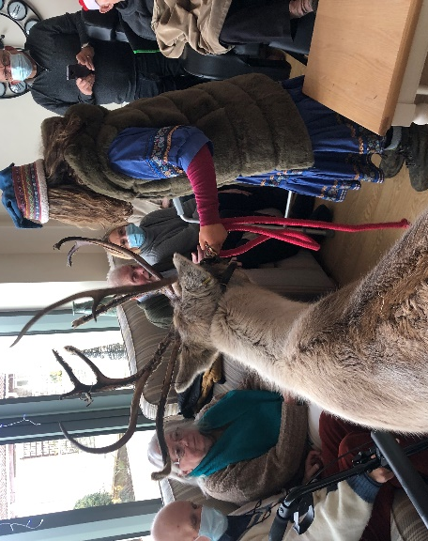
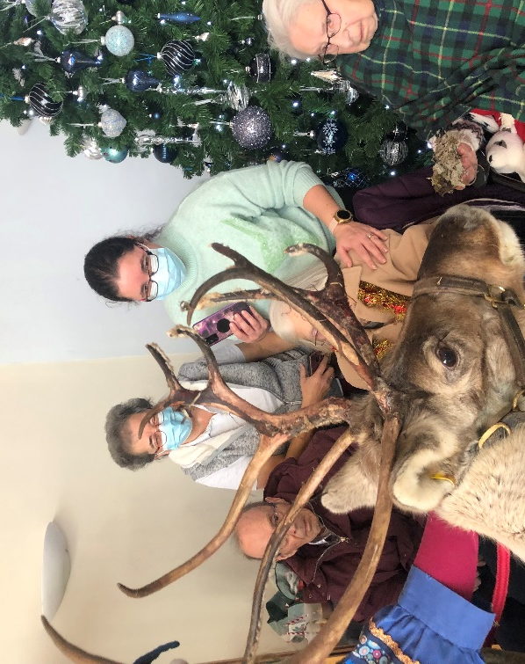
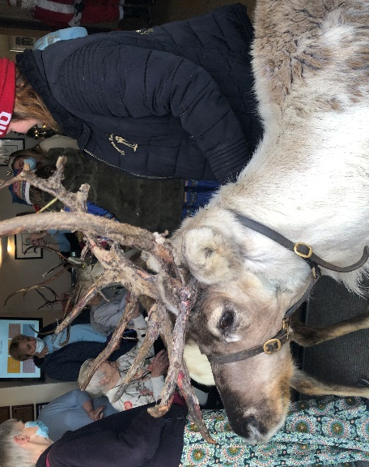
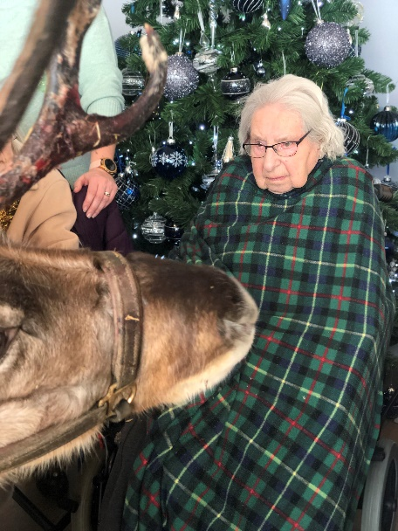
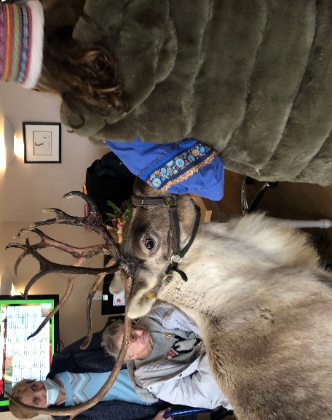
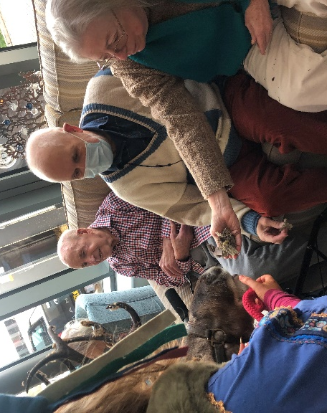
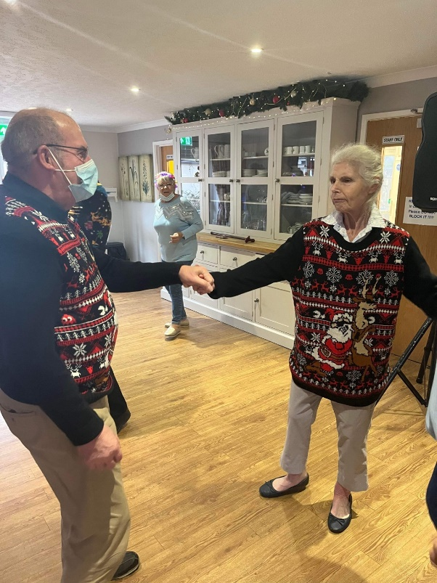
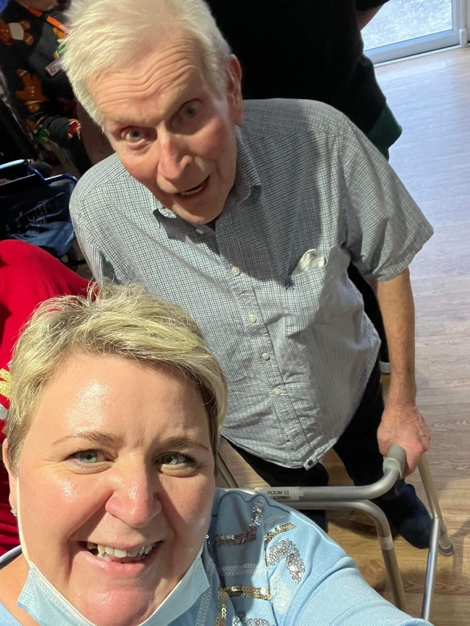
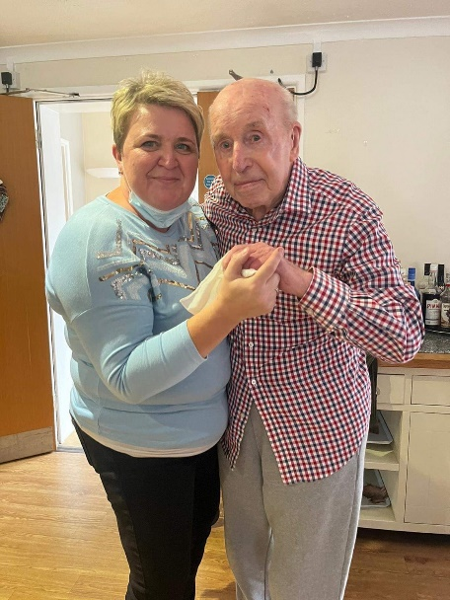

Upcoming Events

Resident’s Meeting
Friday 6th of January 11:30am, Lounge
Armchair Travel
Wednesday 18th of January 10:00am, Lounge
Elvis is in the building
Thursday the 19th January 2.30pm, Dining Room
Special Days

1st Hot Tea Day
3rd J.R.R. Tolkien’s Birthday
6th Epiphany
8th Elvis Presley’s Birthday
16th Martin Luther King Day
19th International Flower Day
21st International Hug Day
22nd Chinese New Year
25th Robert Burns Day
26th Australia Day
27th Mozart’s Birthday
29th Sundance Film Festival

Pet Therapy
Wednesday the 25th January, Lounge
Regular Events

Knit and Natter every Monday and Friday 2pm

Tuneful Tuesdays every Tuesday morning at 10am

Morning Worship Service every Monday 11:30am

Hairdresser every 2nd Monday and Tuesday from 9am

Bingo! 2:30pm Tuesdays

Book Club with Richard Every Wednesday at 2:30pm
Watch this space for a new group starting soon!

January Birthdays

In January, we celebrate birthdays with:

- Mr Nobody
- Mrs Nobody

Would you know it… January is the only month of the year
where nobody at Castle House has a birthday! Cheap Round….

Capricorn (Dec 22 – Jan 19)
Capricorns are responsible, disciplined and have good manners

Aquarius (Jan 20 – Feb 18)
Aquarians are shy & quiet deep thinkers who love helping others.
Elvis Presley, Singer, 8th January 1935
Stephen Hawkins, Physicist, 8th January 1942
David Bowie, Singer, 8th January 1947
Martin Luther King Jr., Activist, 15th January 1929
Muhammad Ali, Boxer, 17th January 1942
Betty White, Actress, 17th January 1922
Michelle Obama, First Lady, 17th January 1964
Kevin Costner, Actor, 18th January 1955
Janis Joplin, Singer, 19th January 1943
Neil Diamond, Rock Singer, 24th January 1941
Virginia Woolf, Novelist, 25th January 1882
There are more twins now than ever before.
In 1915, one in every 50 babies born was a twin – this has now increased to 1 in 30. Scientists believe this trend is due to the fact that older women tend to have more twins, and women are choosing to start families later. Fertility treatments such as in-vitro fertilization likely also play a role.

Poem to Share

“Hope” is the thing with feathers
by Emily Dickinson

“Hope” is the thing with feathers –
That perches in the soul –
And sings the tune without the words –
And never stops – at all –

And sweetest – in the Gale – is heard –
And sore must be the storm –
That could abash the little Bird
That kept so many warm –

I’ve heard it in the chillest land –
And on the strangest Sea –
Yet – never – in Extremity,
It asked a crumb – of me.

Noticeboard
New Staff
A warm welcome also goes to the people who joined our team in the past few months!
- Irma (RN)
- Zoe (HCA)
- Lauren (Wellbeing)
We hope that you enjoy your time here!
Continuous Improvement
Residents, families and friends are reminded that there are a number of avenues available for you to express your views, suggestions and complaints.

Can you Contribute?
Contributions to our newsletter are encouraged and appreciated!
Articles, photos, reports on community outings, staff news, trivia, poems and amusing stories relating to residents and staff are most welcome.
Please hand in your submission to reception, or email us anytime.
Thank you!

In Memoriam
To the families and friends of our late residents—may you be comforted by the knowledge that your loved ones are at peace.
- Mrs Heather Price
- Mrs Aileen Jones
- Ms Lilian Whitcombe
- Mrs Trish Garland
- Mrs Iris Webber

Visiting
We are still officially classed as in outbreak, therefore, visitors should still attend one person per resident at a time.
Thank you for your cooperation.

CHANGE OVER OF BOOKS
We have lots of new books on our shelves, please borrow them, there’s something for everyone. If you would like someone to read to you, please speak to the Wellbeing Team and this will be arranged.

THANK YOU
We would like to issue a heartfelt thanks to relatives, volunteers and staff who organised and supported our Christmas Party on the 14th Dec! A fantastic time was had by all.
A special thank you to the Children of Lovington Primary School Choir, the Christmas Caroler’s, The Wheat Hill Benefice Choir, and Marks & Spencer’s for supplying us with their ‘too good to go’ flowers and plants so that we can enjoy them.

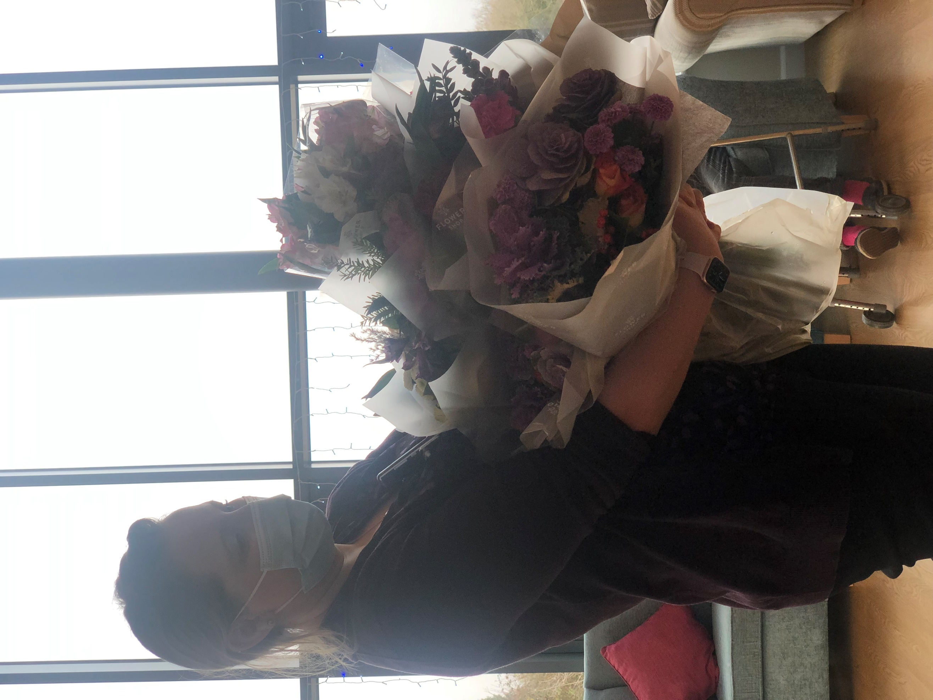

Hairdresser
We have Mandy, our hairdresser who attends alternate Mondays/Tuesdays. If you would like an appointment, please talk to reception, or ask a staff member to write your name down in the hairdresser’s book.

manicures
Complimentary manicures are always available, speak to a member of Wellbeing to get booked in.
Manicures aren’t just for the ladies, men welcome too.

AROMATHERAPY
We are thinking about introducing aromatherapy sessions for those residents who would like to try.
If this is something you think might interest you please speak to Lou.

Laughing Matters

Somebody
This is a story about four people named Everybody, Somebody, Anybody and Nobody.
There was an important job to be done and Everybody was sure that Somebody would do it.
Anybody could have done it, but Nobody did.
Somebody got angry about this, because it was Everybody’s job.
Everybody thought Anybody could do it, but Nobody realized that Everybody wouldn’t do it.
It ended up that Everybody blamed Somebody when Nobody did what Anbody could have done!
The minister
A minister, after listening to an impromptu campaign speech from a hopeful candidate for Mayor said.
“Before I vote for you, I’d like to know if you partake of intoxicating beverages.”
Candidate: “Before I answer, tell me if it is an inquiry or an invitation.”

The bus driver
A woman with a small child boards a bus and pays only her fare to the driver.
“That kid’s older than five,” says the driver. “You’ll have to pay half fare for him.”
“He is certainly not 5!” said the woman. “I’ve been married only four years.”
“Madam,” says the driver, “I take fares, not confessions.”

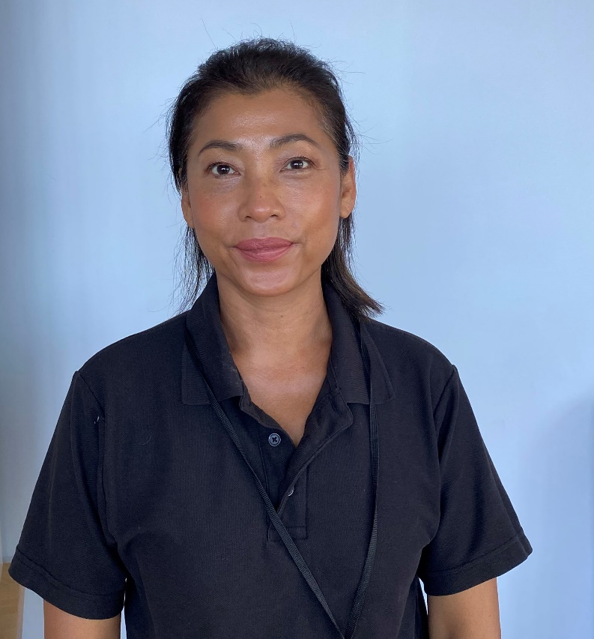

Spotlight

Pim

Pim is a valued member of our Domestic Team, she lives in the village with her two sons.

Pim has a not-so-secret talent cooking Thai food and runs her own Thai food take away from the village hall, she has quite the reputation for her culinary expertise. I’m thinking a theme dinner might be on the cards soon.

When she isn’t cooking or cleaning, Pim likes to play tennis at the local tennis club, fingers crossed for some dry weather for Pim to be able to get her racket out.

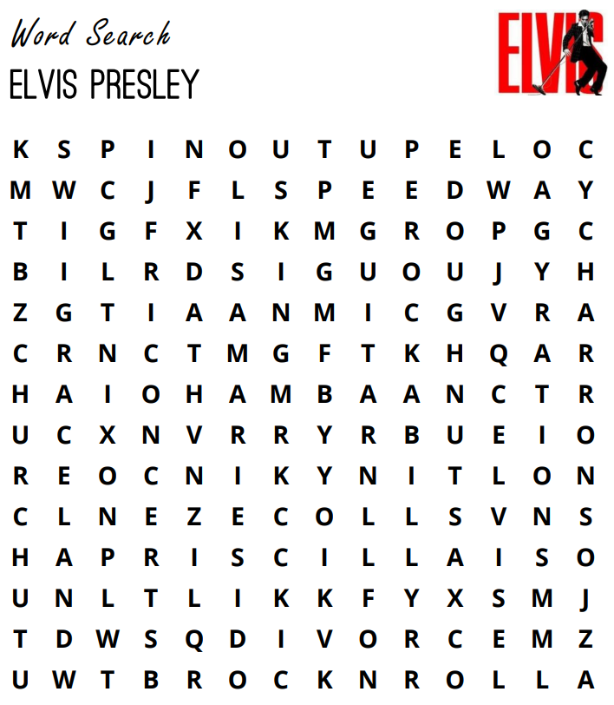
MGM Graceland Concerts Nixon
Divorce Spinout Charro Rockabilly
Grammy Tupelo Church Guitar
Doughnuts Rocknroll Gyrations Military
Priscilla King Elvis Lisa Marie

