NEWSLETTER October 2022

Castle House Nursing Home Ltd.
We Care Enough To Make A Difference

IN THIS ISSUE

  - Editor’s Desk ..………… 2
  - Month in Review ………. 3
  - Upcoming Events …….. 5
  - October Calendar ……… 6
  - October Birthdays …….. 8
  - A Poem to Share .…….. 9
  - Noticeboard ……………. 10
  - Laughing Matters …….. 12
  - Spotlight ………………… 13
  - Word Scramble ………… 14

Editor’s Desk
Hello Residents, Families and Friends!
Lots of people have asked if they missed the September newsletter, unfortunately it didn’t get completed due to several reasons, hopefully, this edition will make up for it.
We are enjoying autumn and the activities that usher the season into the home, we’re especially enjoying the colours, and we are looking forward to a virtual visit to an arboretum.
We are trying to get out for walks on dry days to take in the autumn colours and scents that fill the air
Keep Safe!
Lou
Quote of the Day
Happiness is
a form of courage
– Holbrook Jackson

October Trivia

October derives its name from octo, the Latin word meaning eight, as October was the eighth month of the old Roman calendar.

Zodiac signs: Libra & Scorpio
Birthstone: Opal & Tourmaline
Flower: Calendula

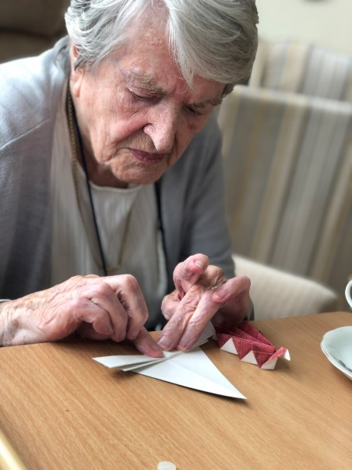

Origami

Folding autumnal coloured paper, we created leaves.

Exercising our fingers and putting our fine motor skills to the test. We are rather pleased with the results.
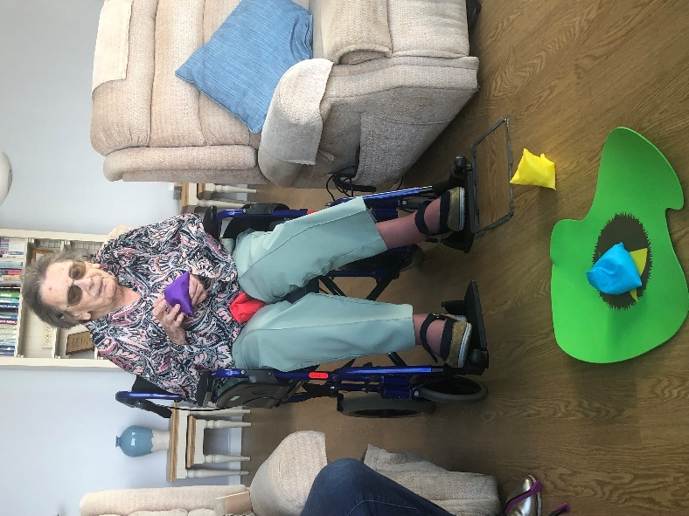
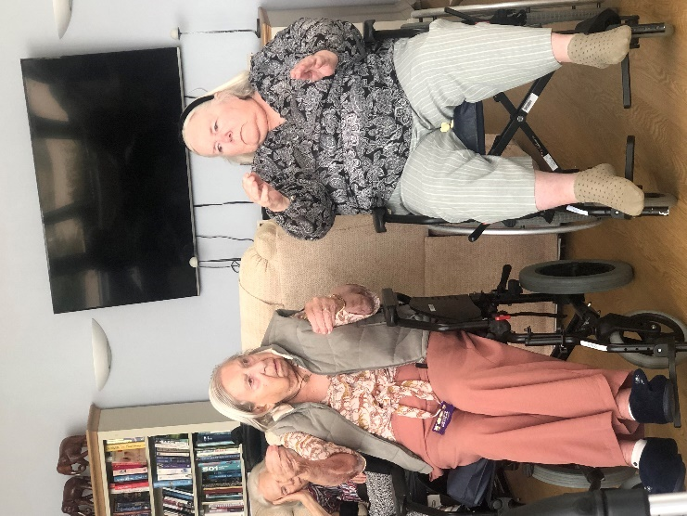
Music and Movement

We are all aware just how important it is to keep on moving, exercising to within our capabilities.

We exercise to all genres of music depending on how energetic we are feeling, from Beach Boys to Bach
Hand Eye Coordination

A round of target golf went down a storm, aiming the beanbag at the target to try and get a hole in one.

We surprised ourselves at just how good our hand eye coordination was.
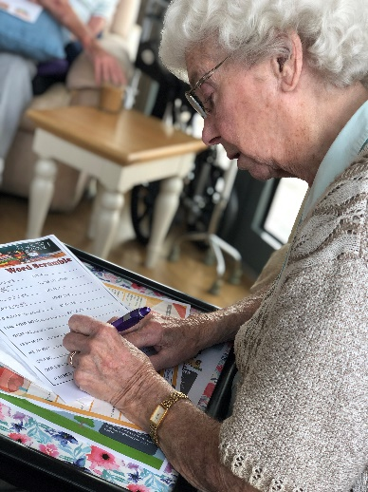
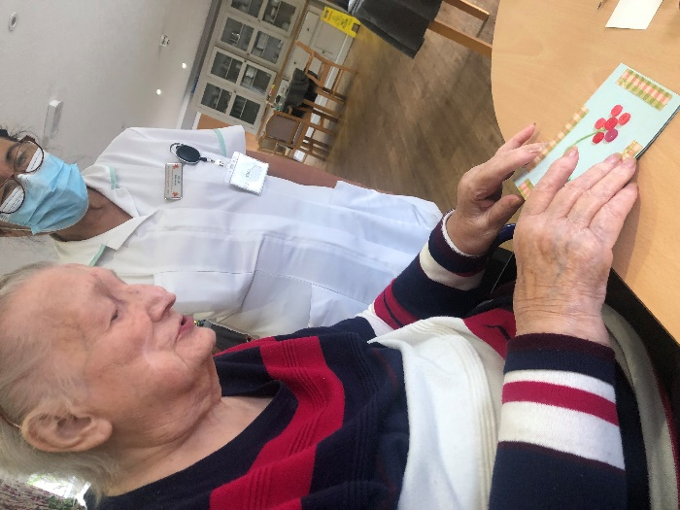
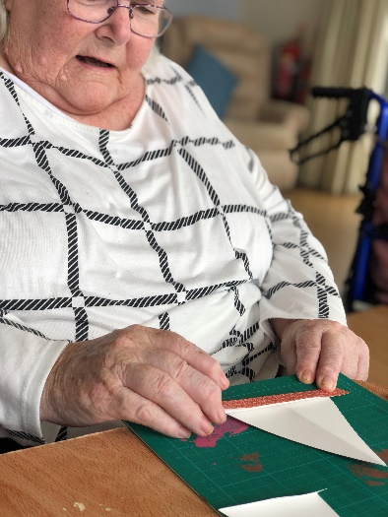
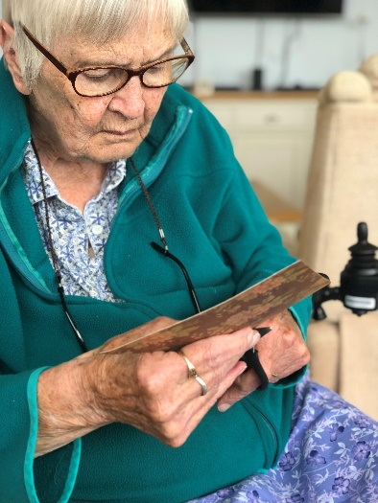
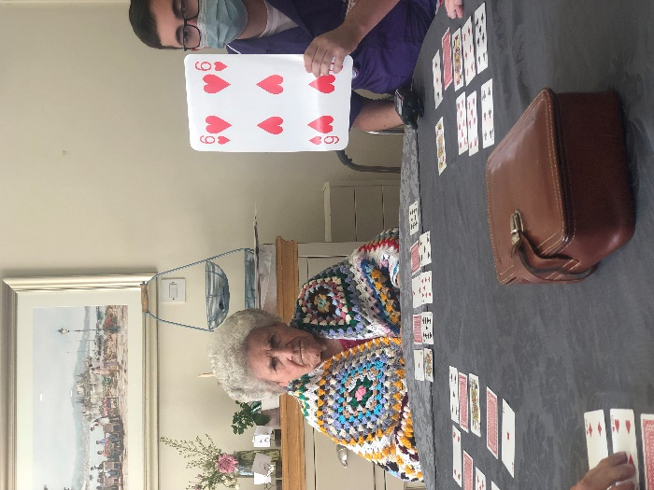
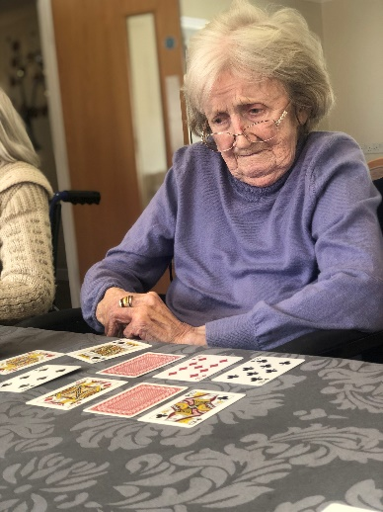
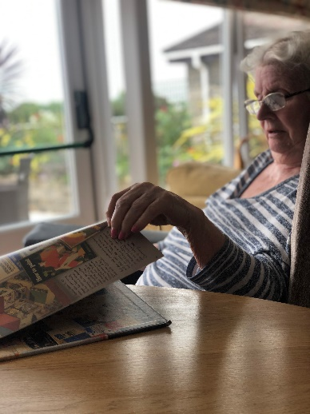
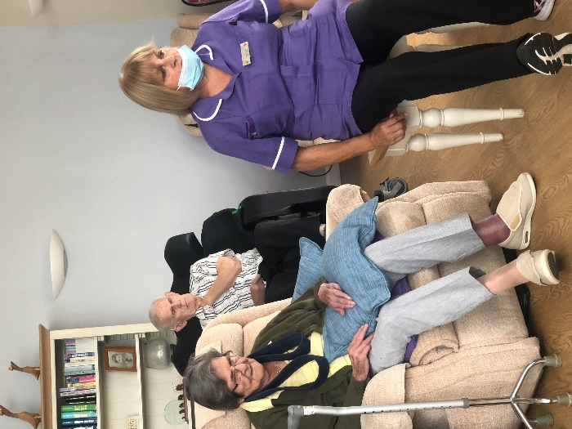
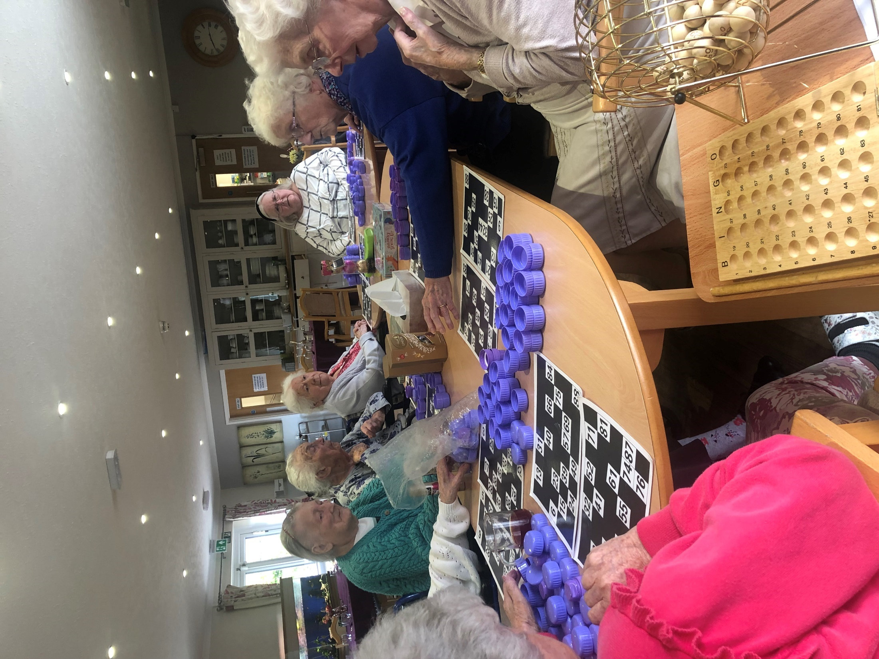
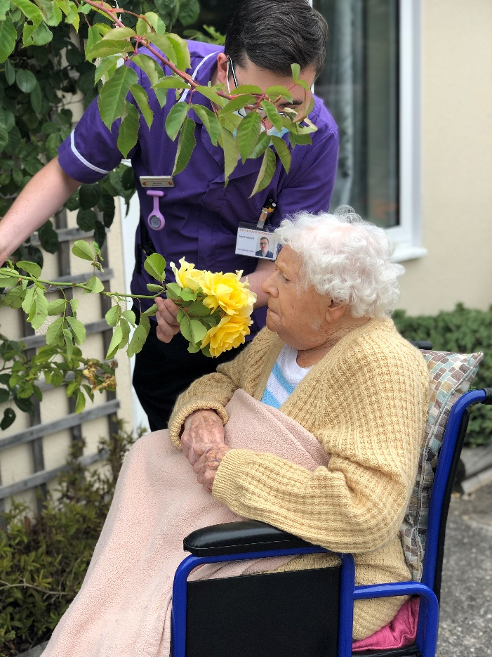
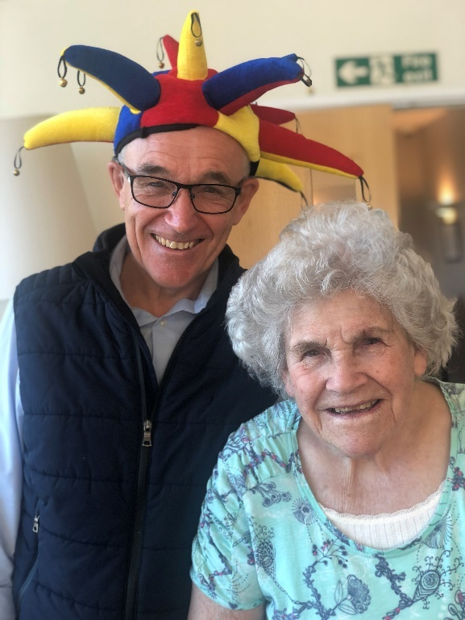
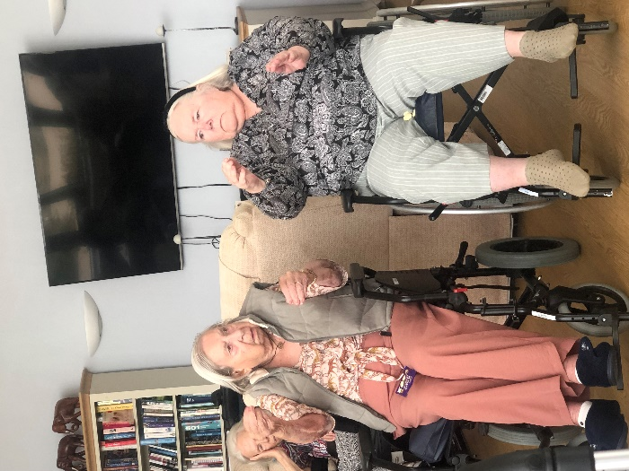
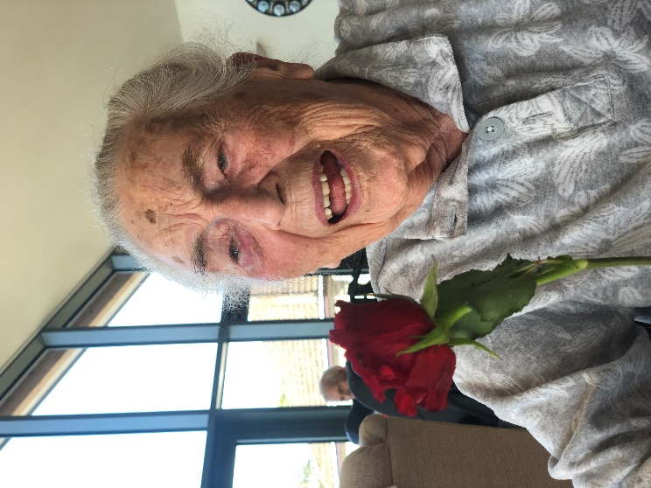
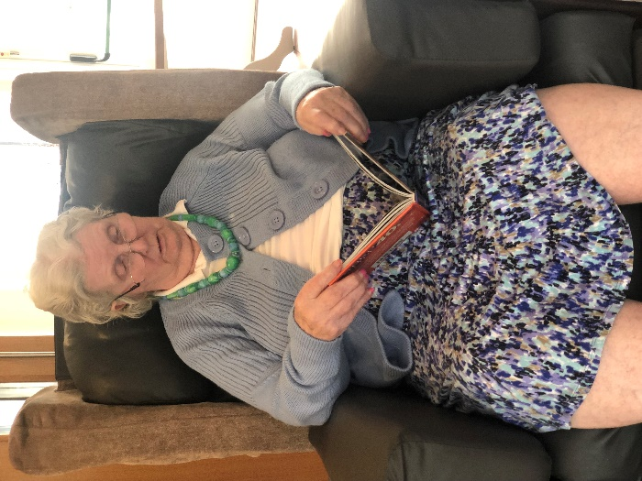

Upcoming Events

Celebration Tea
Friday 21st October 5.00pm, Dining Room
Resident’s Meeting
Monday 24th October 11:00am, Lounge
Armchair Travel
Wednesday 26th October 9:30am, Lounge
Special Days
1st Intl. Day of Older Persons
1st Intl. Music Day
1st Residents’ Rights Month
1st World Ballet Day
4th World Animal Day
4th World Space Week
5th World Teachers Day
10th Columbus Day
10th Thanksgiving (Canada)
25th Pablo Picasso’s Birthday
31st Halloween
Multicultural Day
Thursday x of October, 2:00pm, Recreation Area
Memorial
Sunday 6th November 4.00pm, Lounge

Regular Events

Faith Service every Monday 11.30am
Hairdresser every second Monday/Tuesday
Culture Club every Tuesday at 2pm
Bingo! Every Tuesday 2.30pm
Coffee and Conversation Friday 10.30am

October Birthdays

In October, we celebrate birthdays with:

- Angela Romero
- Stephen Sullivan
- Jane Doe

Please join us in the recreation room on the first Sunday
in October to celebrate!

Libra (Oct 23 - Oct 22)
Librans are often considered the nicest and most charming personality in the world!

Scorpio (Nov 23 – Nov 22)
Competitive, passionate, independent, and unafraid to blaze their own trail no matter what others think.
Julie Andrews, Actor, 1st October 1935
Chevy Chase, Actor, 8th October 1943
John Lennon, Musician, 9th October 1940
Hugh Jackman, Actor, 12th October 1968
Margaret Thatcher, Prime Minister, 13th October 1925
Rita Hayworth, Actress, 17th October 1918
Joan Fontaine, Actress, 22nd October 1917
Pablo Picasso, Painter, 25th October 1881
Carrie Fisher, Actress, 21st October 1956
Bill Gates, Philanthropist, 28th October 1965

October Spotlight: Transcontinental Telegraph
On October 24 1861, the first transcontinental telegraph system was completed, making it possible to transmit messages rapidly (by mid-19th-century standards) from coast to coast.

Poem to Share

A Dream Within A Dream
BY EDGAR ALLAN POE

Take this kiss upon the brow!
And, in parting from you now,
Thus much let me avow-
You are not wrong, who deem
That my days have been a dream;
Yet if hope has flown away
In a night, or in a day,
In a vision, or in none,
Is it therefore the less gone?
All that we see or seem
Is but a dream within a dream.

I stand amid the roar
Of a surf-tormented shore,
And I hold within my hand
Grains of the golden sand-
How few! yet how they creep
Through my fingers to the deep,
While I weep- while I weep!
O God! can I not grasp
Them with a tighter clasp?
O God! can I not save
One from the pitiless wave?
Is all that we see or seem
But a dream within a dream?.
New Residents
A very warm welcome to:
- Mrs Shirley McDonald
- Mrs Helen Sullivan
- Mr Emmanuel Salvador
We hope that you enjoy your time here!
Continuous Improvement
Residents, families and friends are reminded that there are a number of avenues available for you to express your views, suggestions and complaints.
There are feedback forms available outside the Recreation Room. We are happy to receive feedback at any time and strongly encourage everyone to contribute so that we can ensure that we continue to do the BEST we can.

Noticeboard

New Staff
A warm welcome also foes to the people who joined our team in the past few month!
- Nola Neradi
- Sharmilla Gooda
- David Smith
We hope that you enjoy your time here!

Can you Contribute?
Contributions to our newsletter are encouraged and appreciated!
Articles, photos, reports on community outings, staff news, trivia, poems and amusing stories relating to residents and staff are most welcome.
Please hand in your submission to reception, or email us anytime.
Thank you!

In Memoriam
To the families and friends of our late residents—may you be comforted by the knowledge that your loved ones are at peace.
- Mrs Alfie Campo
- Mr Sam Regali
- Mr Ron Lain

Noticeboard
LIBRARY SERVICE
We have a mobile library service that delivers & picks up library books to resident’s rooms. If you would like this service, please talk to a staff member.
THANK YOU
We would like to issue a heart felt thanks to relatives and volunteers who support us day in and day out. You make such a difference and we so very much appreciate your time and energy.

Hairdresser
We have a hairdressser who attends every Monday. If you would like an appointment please talk to reception or ask a staff member to write your name down in the hairdressers book.
Lorem Ipsum
Lorem ipsum dolor sit amet, consectetuer adipiscing elit. Maecenas porttitor congue massa. Fusce posuere, magna sed pulvinar ultricies, purus lectus malesuada.

Cultural Celebration
In the month of August we celebrate Indian Independence Day. Watch your calendar for related activities in the recreation room.
Lorem Ipsum
Lorem ipsum dolor sit amet, consectetur adipiscing elit, sed do eiusmod tempor incididunt ut labore et dolore magna aliqua.
Eiusmod tempor incididunt ut labore et dolore magna aliqua.

Laughing Matters

Backseat Driving
A wife was making a breakfast of fried eggs for her husband.
Suddenly, her husband burst into the kitchen. 'Careful,' he said, 'CAREFUL! Put in some more butter! OH MY GOSH! You're cooking too many at once. TOO MANY! Turn them! TURN THEM NOW! We need more butter. OH MY GOSH! WHERE are we going to get MORE BUTTER? They're going to STICK! Careful. CAREFUL! I said be CAREFUL! You NEVER listen to me when you're cooking! Never! Turn them! Hurry up! Are you CRAZY? Have you LOST your mind? Don't forget to salt them! You know you always forget to salt them. Use the salt. USE THE SALT! THE SALT!'
The wife stared at him. 'What in the world is wrong with you? You think I don't know how to fry a couple of eggs?'
The husband calmly replied, 'I just wanted to show you what it feels like when I'm driving.'

Police Radar
A state policeman pulls over a speeding car.
"I was only going 40!" the driver protests.
"Not according to my radar." says the policeman.
"Yes I was!" the man shouts back.
"No you weren't." the policeman says.
With that the man's wife leans towards the window and says:
"Officer, I should warn you not to argue with my husband when he's been drinking".

Famous Quotes
Instead of getting married again, I'm going to find a woman I don't like and just give her a house. - Rod Stewart
I was married by a judge. I should have asked for a jury. -- Groucho Marx

Spotlight

Augustus Romero

Write a short bio about a resident or staff member here, including a pic.

